UNITED STATES
SECURITIES AND EXCHANGE COMMISSION
Washington, D.C. 20549
FORM 8-K
CURRENT REPORT
Pursuant to Section 13 or 15(d) of the
Securities Exchange Act of 1934
Date of Report (Date of earliest event reported): October 22, 2026
VERISIGN, INC.
(Exact Name of Registrant as Specified in its Charter)
Delaware
(State or Other Jurisdiction of Incorporation)
000-23593 |  |  |  |  |  | 94-3221585
(Commission  File Number) |  |  |  |  |  | (IRS Employer  Identification No.)
12061 Bluemont Way,
Reston, |  |  | Virginia |  |  |  |  |  | 20190
(Address of principal executive offices) |  |  |  |  |  |  |  |  | (Zip Code)
(703) 948-3200
(Registrant’s Telephone Number, Including Area Code)
Not applicable
(Former Name or Former Address, if Changed Since Last Report)
Check the appropriate box below if the Form 8-K filing is intended to simultaneously satisfy the filing obligation of the registrant under any of the following provisions:
☐ |  |  | Written communications pursuant to Rule 425 under the Securities Act (17 CFR 230.425)
☐ |  |  | Soliciting material pursuant to Rule 14a-12 under the Exchange Act (17 CFR 240.14a-12)
☐ |  |  | Pre-commencement communications pursuant to Rule 14d-2(b) under the Exchange Act (17 CFR 240.14d-2(b))
☐ |  |  | Pre-commencement communications pursuant to Rule 13e-4(c) under the Exchange Act (17 CFR 240.13e-4(c))
Securities registered pursuant to Section 12(b) of the Act:
Title of each class |  |  | Trading Symbol(s) |  |  | Name of each exchange on which registered
Common Stock, $0.001 Par Value Per Share |  |  | VRSN |  |  | Nasdaq Global Select Market
Indicate by check mark whether the registrant is an emerging growth company as defined in Rule 405 of the Securities Act of 1933 (§230.405 of this chapter) or Rule 12b-2 of the Securities Exchange Act of 1934 (§240.12b-2 of this chapter).
 |  |  | Emerging growth company |  |  | ☐
If an emerging growth company, indicate by check mark if the registrant has elected not to use the extended transition period for complying with any new or revised financial accounting standards provided pursuant to Section 13(a) of the Exchange Act. |  |  |  |  |  | ☐

Item 2.02. |  |  | Results of Operations and Financial Condition.
On October 22, 2026, VeriSign, Inc. issued a press release reporting its financial results for the fiscal quarter ended September 30, 2026. A copy of this press release is attached hereto as Exhibit 99.1.

The information in this Item 2.02 of Form 8-K and the Exhibit attached hereto shall not be deemed “filed” for purposes of Section 18 of the Securities Exchange Act of 1934, as amended (the “Exchange Act”), nor shall it be deemed incorporated by reference in any filing under the Securities Act of 1933, as amended, or the Exchange Act, except as shall be expressly set forth by specific reference in such filing.
Item 9.01. |  |  | Financial Statements and Exhibits.
(d) Exhibits
Exhibit  Number |  |  |  |  |  | Description
99.1 |  |  |  |  |  | Press release of VeriSign, Inc. issued on October 22, 2026.
104 |  |  |  |  |  | Inline XBRL for the cover page of this Current Report on Form 8-K

SIGNATURES
Pursuant to the requirements of the Securities Exchange Act of 1934, the registrant has duly caused this report to be signed on its behalf by the undersigned hereunto duly authorized.

 |  |  |  |  |  | VERISIGN, INC.
Date: October 22, 2026 |  |  |  |  |  | By: |  |  |  |  |  | /s/ Thomas C. Indelicarto
 |  |  |  |  |  | Thomas C. Indelicarto
 |  |  |  |  |  | Executive Vice President, General Counsel and Secretary

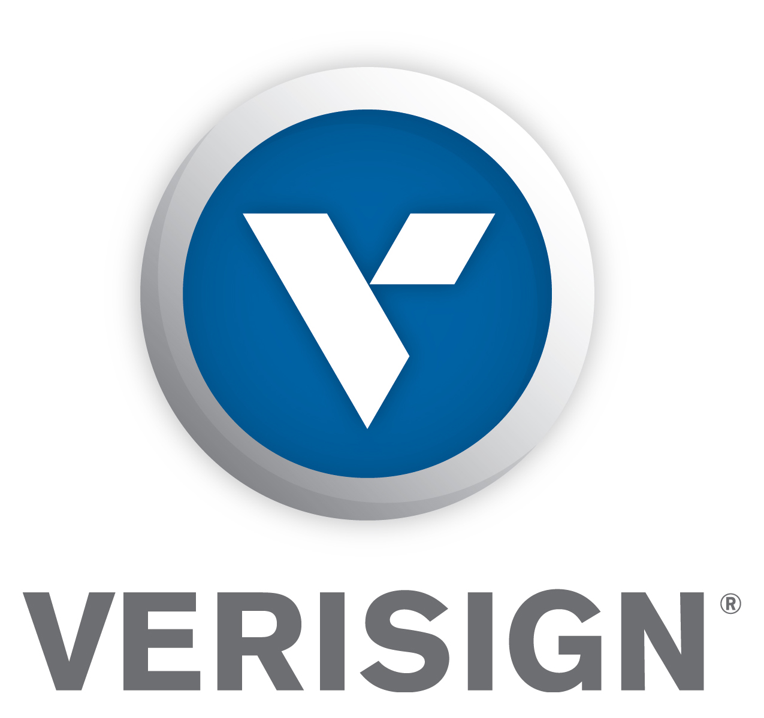

Verisign Reports Third Quarter 2026 Results

RESTON, VA - Oct. 22, 2026 - VeriSign, Inc. (NASDAQ: VRSN), a global provider of critical internet infrastructure and domain name registry services, today reported financial results for the third quarter of 2026.

VeriSign, Inc. and its subsidiaries (“Verisign”) reported revenue of $443 million for the third quarter of 2026, up 5.7 percent from the same quarter in 2025. Operating income was $296 million for the third quarter of 2026, compared to $284 million for the same quarter of 2025. Verisign reported net income of $213 million and diluted earnings per share (diluted “EPS”) of $2.35 for the third quarter of 2026, compared to net income of $213 million and diluted EPS of $2.27 for the same quarter of 2025. During the third quarter of 2026 the Company recognized a pre-tax operating loss of $7.5 million related to certain assets held for sale, which decreased diluted EPS by $0.06.

“We delivered a strong quarter operationally, having grown the domain name base by 6.1% year-over-year. The rollout of the .web top-level domain is on track, and we opened the limited beta phase of our high-assurance validation service, Verisign Informed™, which can strengthen and enhance existing tools of trust that are deployed world-wide for authenticating data and users,” said Jim Bidzos, Executive Chairman, President and Chief Executive Officer.
Financial Highlights

•Verisign ended the third quarter of 2026 with cash, cash equivalents and marketable securities of $476 million, a decrease of $104 million from year-end 2025.
•Cash flow from operations was $268 million for the third quarter of 2026, compared to $308 million for the same quarter of 2025.
•Deferred revenues as of September 30, 2026, totaled $1.46 billion, an increase of $79 million from year-end 2025.
•During the third quarter of 2026, Verisign repurchased 0.7 million shares of its common stock for an aggregate cost of $189 million. As of September 30, 2026, there was $1.36 billion remaining for future share repurchases under the share repurchase program, which has no expiration.
•On October 19, 2026, Verisign’s Board of Directors approved a cash dividend of $0.81 per share of Verisign’s outstanding common stock to stockholders of record as of the close of business on November 17, 2026, payable on November 24, 2026.

Business Highlights
•Verisign ended the third quarter of 2026 with 182.5 million .com and .net domain name registrations in the domain name base, a 6.1 percent increase from the end of the third quarter of 2025, and a net increase of 3.36 million domain names during the third quarter of 2026.
•During the third quarter of 2026, Verisign processed 13.1 million new domain name registrations for .com and .net, compared with 10.6 million for the third quarter of 2025.
•The final .com and .net renewal rate for the second quarter of 2026 was 75.2 percent compared to 75.5 percent for the same quarter of 2025. Renewal rates are not fully measurable until 45 days after the end of the quarter.

Today’s Conference Call
Verisign will host a live conference call today at 4:30 p.m. (EDT) to review the third quarter 2026 results. The call will be accessible by direct dial at (888) 676-VRSN (U.S.) or (646) 769-9200 (international), conference ID: Verisign. A listen-only live web cast of the conference call and accompanying slide presentation will also be available at https://investor.verisign.com.

An audio archive of the call will be available at https://investor.verisign.com/events.cfm. This news release and the financial information discussed on today’s conference call are available at https://investor.verisign.com.

About Verisign
Verisign (NASDAQ: VRSN), a global provider of critical internet infrastructure and domain name registry services, enables internet navigation for many of the world’s most recognized domain names. Verisign helps enable the security, stability, and resiliency of the Domain Name System and the internet by providing root zone maintainer services, operating two of the 13 global internet root servers, and providing registration services and authoritative resolution for the .com and .net top-level domains, which support the majority of global e-commerce. To learn more please visit verisign.com.

Statements in this announcement other than historical data and information constitute forward-looking statements within the meaning of Section 27A of the Securities Act of 1933 as amended and Section 21E of the Securities Exchange Act of 1934 as amended. These statements involve risks and uncertainties that could cause our actual results to differ materially from those stated or implied by such forward-looking statements. The potential risks and uncertainties include, among others, attempted security breaches, cyber-attacks, and DDoS attacks against our systems and services; the introduction of undetected or unknown defects in our systems or services; vulnerabilities in the global routing system; system interruptions or system failures; advances in quantum computing; damage or interruptions to our data centers, data center systems or resolution systems; increases in the cost of compute and network hardware; risks arising from our operation of root servers and our performance of the Root Zone Maintainer functions; unsuccessful strategic initiatives or launches of new products or services; any loss or modification of our right to operate the .com and .net gTLDs; changes or challenges to the pricing provisions of the .com Registry Agreement; new or existing governmental laws and regulations in the U.S. or other applicable non-U.S. jurisdictions; new laws, regulations, directives or ICANN policies that require us to obtain and maintain personal information of registrants; economic, legal, regulatory, and political risks associated with our international operations; unfavorable changes in, or interpretations of, tax rules and regulations; risks from the implementation of ICANN’s consensus and temporary policies, technical standards and other processes; the weakening of, or changes to, the multi-stakeholder model of internet governance; the outcome of claims, lawsuits, audits or investigations; challenging economic conditions; our ability to compete in the highly competitive business environment in which we operate; changes in internet practices and behavior and the adoption of substitute technologies, or the negative impact of wholesale price increases; our ability to expand our services into developing and emerging economies; our ability to maintain strong relationships with registrars and their resellers; our ability to attract, retain and motivate highly skilled employees; the continuity of our quarterly dividend; our ability to protect and enforce our intellectual property rights; challenges from the use of AI technology by third-parties, autonomous agents, or us; and the impact on our stock price from the dissemination of false or misleading information by unrelated third parties. More information about potential factors that could affect our business and financial results is included in our filings with the SEC, including in our Annual Report on Form 10-K for the year ended Dec. 31, 2025, our Quarterly Report on Form 10-Q for the quarter ended Sept. 30, 2026 and Current Reports on Form 8-K. Verisign undertakes no obligation to update any of the forward-looking statements after the date of this announcement.

Contacts
Investor Relations: David Atchley, datchley@verisign.com, 703-948-3447
Media Relations: David McGuire, davmcguire@verisign.com, 703-948-3800

©2026 VeriSign, Inc. All rights reserved. VERISIGN, the VERISIGN logo, and other trademarks, service marks, and designs are registered or unregistered trademarks of VeriSign, Inc. and its subsidiaries in the United States and in foreign countries. All other trademarks are property of their respective owners.

VERISIGN, INC.
CONDENSED CONSOLIDATED BALANCE SHEETS
(In millions, except par value)
(Unaudited)
 |  |  | September 30,  2026 |  |  |  |  |  | December 31,  2025
ASSETS
Current assets:
Cash and cash equivalents |  |  | $ | 206.8 |  |  |  |  | $ | 307.9
Marketable securities |  |  | 269.3 |  |  |  |  |  | 272.6
Other current assets |  |  | 97.4 |  |  |  |  |  | 72.0
Total current assets |  |  | 573.5 |  |  |  |  |  | 652.5
Property and equipment, net |  |  | 221.2 |  |  |  |  |  | 213.7
Goodwill |  |  | 52.5 |  |  |  |  |  | 52.5
Intangible assets |  |  | 171.4 |  |  |  |  |  | —
Deferred tax assets |  |  | 218.1 |  |  |  |  |  | 233.2
Deposits to acquire intangible assets |  |  | — |  |  |  |  |  | 145.2
Other long-term assets |  |  | 43.4 |  |  |  |  |  | 28.8
Total long-term assets |  |  | 706.6 |  |  |  |  |  | 673.4
Total assets |  |  | $ | 1,280.1 |  |  |  |  | $ | 1,325.9
LIABILITIES AND STOCKHOLDERS’ DEFICIT
Current liabilities:
Accounts payable and accrued liabilities |  |  | $ | 286.8 |  |  |  |  | $ | 298.0
Deferred revenues |  |  | 1,094.4 |  |  |  |  |  | 1,035.1
Total current liabilities |  |  | 1,381.2 |  |  |  |  |  | 1,333.1
Long-term deferred revenues |  |  | 368.9 |  |  |  |  |  | 349.4
Long-term senior notes |  |  | 1,785.9 |  |  |  |  |  | 1,788.2
Other long-term liabilities |  |  | 28.8 |  |  |  |  |  | 9.4
Total long-term liabilities |  |  | 2,183.6 |  |  |  |  |  | 2,147.0
Total liabilities |  |  | 3,564.8 |  |  |  |  |  | 3,480.1
Commitments and contingencies
Stockholders’ deficit:
Preferred stock—par value $.001 per share; Authorized shares: 5.0; Issued and outstanding shares: none |  |  | — |  |  |  |  |  | —
Common stock and additional paid-in capital—par value $.001 per share; Authorized shares: 1,000; Issued shares: 355.9 at September 30, 2026 and 355.6 at December 31, 2025; Outstanding shares: 89.8 at September 30, 2026 and 91.9 at December 31, 2025 |  |  | 8,849.6 |  |  |  |  |  | 9,623.5
Accumulated deficit |  |  | (11,131.4) |  |  |  |  |  | (11,775.0)
Accumulated other comprehensive loss |  |  | (2.9) |  |  |  |  |  | (2.7)
Total stockholders’ deficit |  |  | (2,284.7) |  |  |  |  |  | (2,154.2)
Total liabilities and stockholders’ deficit |  |  | $ | 1,280.1 |  |  |  |  | $ | 1,325.9

VERISIGN, INC.
CONDENSED CONSOLIDATED STATEMENTS OF COMPREHENSIVE INCOME
(In millions, except per share data)
(Unaudited)
 |  |  | Three Months Ended September 30, |  |  |  |  |  |  |  |  |  |  |  | Nine Months Ended September 30,
 |  |  | 2026 |  |  |  |  |  | 2025 |  |  |  |  |  | 2026 |  |  |  |  |  | 2025
Revenues |  |  | $ | 443.0 |  |  |  |  | $ | 419.1 |  |  |  |  | $ | 1,306.5 |  |  |  |  | $ | 1,231.3
Costs and expenses:
Cost of revenues |  |  | 49.8 |  |  |  |  |  | 48.8 |  |  |  |  |  | 149.0 |  |  |  |  |  | 147.3
Research and development |  |  | 26.5 |  |  |  |  |  | 25.4 |  |  |  |  |  | 81.5 |  |  |  |  |  | 77.1
Selling, general and administrative |  |  | 70.2 |  |  |  |  |  | 60.6 |  |  |  |  |  | 189.6 |  |  |  |  |  | 170.7
Total costs and expenses |  |  | 146.5 |  |  |  |  |  | 134.8 |  |  |  |  |  | 420.1 |  |  |  |  |  | 395.1
Operating income |  |  | 296.5 |  |  |  |  |  | 284.3 |  |  |  |  |  | 886.4 |  |  |  |  |  | 836.2
Interest expense |  |  | (21.2) |  |  |  |  |  | (18.9) |  |  |  |  |  | (59.3) |  |  |  |  |  | (58.1)
Non-operating income, net |  |  | 4.3 |  |  |  |  |  | 6.3 |  |  |  |  |  | 13.5 |  |  |  |  |  | 19.3
Income before income taxes |  |  | 279.6 |  |  |  |  |  | 271.7 |  |  |  |  |  | 840.6 |  |  |  |  |  | 797.4
Income tax expense |  |  | (67.0) |  |  |  |  |  | (58.9) |  |  |  |  |  | (197.0) |  |  |  |  |  | (177.9)
Net income |  |  | 212.6 |  |  |  |  |  | 212.8 |  |  |  |  |  | 643.6 |  |  |  |  |  | 619.5
Other comprehensive (loss) income |  |  | (0.1) |  |  |  |  |  | 0.1 |  |  |  |  |  | (0.2) |  |  |  |  |  | (0.2)
Comprehensive income |  |  | $ | 212.5 |  |  |  |  | $ | 212.9 |  |  |  |  | $ | 643.4 |  |  |  |  | $ | 619.3
Earnings per share:
Basic |  |  | $ | 2.36 |  |  |  |  | $ | 2.28 |  |  |  |  | $ | 7.08 |  |  |  |  | $ | 6.60
Diluted |  |  | $ | 2.35 |  |  |  |  | $ | 2.27 |  |  |  |  | $ | 7.06 |  |  |  |  | $ | 6.58
Shares used to compute earnings per share
Basic |  |  | 90.1 |  |  |  |  |  | 93.3 |  |  |  |  |  | 90.8 |  |  |  |  |  | 93.9
Diluted |  |  | 90.4 |  |  |  |  |  | 93.6 |  |  |  |  |  | 91.1 |  |  |  |  |  | 94.1

VERISIGN, INC.
CONDENSED CONSOLIDATED STATEMENTS OF CASH FLOWS
(In millions)
(Unaudited)
 |  |  | Nine Months Ended September 30,
 |  |  | 2026 |  |  |  |  |  | 2025
Cash flows from operating activities:
Net income |  |  | $ | 643.6 |  |  |  |  | $ | 619.5
Adjustments to reconcile net income to net cash provided by operating activities:
Depreciation of property and equipment |  |  | 19.8 |  |  |  |  |  | 24.5
Stock-based compensation expense |  |  | 58.8 |  |  |  |  |  | 51.8
Amortization of discount on investments in debt securities |  |  | (5.3) |  |  |  |  |  | (8.2)
Other, net |  |  | 10.2 |  |  |  |  |  | 2.4
Changes in operating assets and liabilities:
Other assets |  |  | (40.4) |  |  |  |  |  | (3.2)
Other liabilities |  |  | (8.5) |  |  |  |  |  | 20.6
Deferred revenues |  |  | 78.9 |  |  |  |  |  | 80.1
Net deferred income taxes |  |  | 15.2 |  |  |  |  |  | 14.0
Net cash provided by operating activities |  |  | 772.3 |  |  |  |  |  | 801.5
Cash flows from investing activities:
Proceeds from maturities and sales of marketable securities |  |  | 354.7 |  |  |  |  |  | 412.5
Purchases of marketable securities |  |  | (346.3) |  |  |  |  |  | (393.6)
Purchases of property and equipment |  |  | (33.6) |  |  |  |  |  | (18.3)
Other investing activities |  |  | (7.7) |  |  |  |  |  | —
Net cash (used in) provided by investing activities |  |  | (32.9) |  |  |  |  |  | 0.6
Cash flows from financing activities:
Repurchases of common stock |  |  | (620.0) |  |  |  |  |  | (627.2)
Repayment of borrowings |  |  | (550.0) |  |  |  |  |  | (500.0)
Proceeds from senior note issuance, net of issuance costs |  |  | 545.0 |  |  |  |  |  | 493.3
Payment of dividends |  |  | (220.8) |  |  |  |  |  | (144.1)
Proceeds from employee stock purchase plan |  |  | 12.7 |  |  |  |  |  | 12.3
Payment of excise tax on repurchase of common stock |  |  | (7.9) |  |  |  |  |  | (11.6)
Net cash used in financing activities |  |  | (841.0) |  |  |  |  |  | (777.3)
Effect of exchange rate changes on cash, cash equivalents, and restricted cash |  |  | 0.5 |  |  |  |  |  | 0.1
Net (decrease) increase in cash, cash equivalents, and restricted cash |  |  | (101.1) |  |  |  |  |  | 24.9
Cash, cash equivalents, and restricted cash at beginning of period |  |  | 309.5 |  |  |  |  |  | 212.1
Cash, cash equivalents, and restricted cash at end of period |  |  | $ | 208.4 |  |  |  |  | $ | 237.0
Supplemental cash flow disclosures:
Cash paid for interest |  |  | $ | 49.9 |  |  |  |  | $ | 55.4
Cash paid for income taxes, net of refunds received |  |  | $ | 195.5 |  |  |  |  | $ | 169.3

